**Ideation Phase**

**Define the Problem Statements**

|  |  |
| --- | --- |
| Date | 26th June 2025 |
| Team ID | LTVIP2025TMID59290 |
| Project Name | FlightFinder |
| Maximum Marks | 2 Marks |

**Customer Problem Statement Template:**

Create a problem statement to understand your customer's point of view. The Customer Problem Statement template helps you focus on what matters to create experiences people will love.

A well-articulated customer problem statement allows you and your team to find the ideal solution for the challenges your customers face. Throughout the process, you’ll also be able to empathize with your customers, which helps you better understand how they perceive your product or service.

Reference: <https://miro.com/templates/customer-problem-statement/>

**Example:**

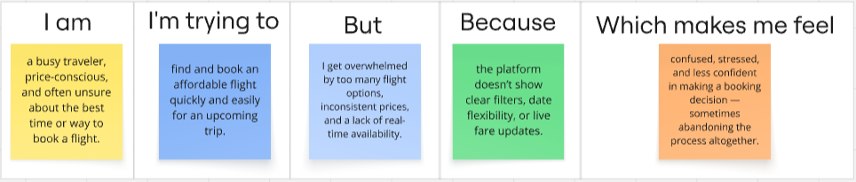

|  |  |  |  |  |  |
| --- | --- | --- | --- | --- | --- |
| **Problem Statement (PS)** | **I am (Customer)** | **I’m trying to** | **But** | **Because** | **Which makes me feel** |
| PS-1 | a frequent traveler | book a convenient flight quickly | most platforms are cluttered and time-consuming | they overload me with too many irrelevant options | frustrated and overwhelmed |
| PS-2 | a user with specific travel preferences | find flights that match my airline, time, and seat choices | filters are often limited or inaccurate | I have loyalty memberships and prefer certain airlines | disappointed and not in control |
| |  | | --- | | **PS-3** |  |  | | --- | |  | | a business professional on a tight schedule | find direct flights with flexible timings | most apps don’t let me filter for exact time slots or avoid layovers easily | my time is limited and I need efficiency | stressed and dissatisfied |
| **PS-4** | a digital-savvy user | complete my entire flight booking on my phone | some platforms are not fully mobile-responsive or glitchy | I expect smooth performance on all devices | annoyed and less likely to return |